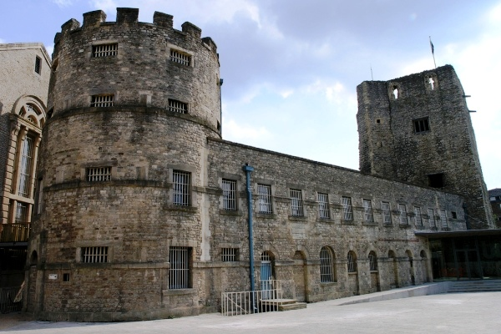

No More Prisons on Earth
Summary: Soon after the young teacher Lucy Allen gets convicted and imprisoned for the deaths she caused by negligence, the prison she lands in turns into paradise.

Court (part 1)
“What happened on the day in question, Miss Allen?”
Sunspear looked up to saw the stern face of the judge. It had come to this. She had made a mistake, a serious mistake. Two children had died and one had serious injuries and she was to blame. But she would not lie or adorn the truth as her attorney had suggested. She would own up to her responsibility. “We were on a weekend school trip, in the Alabaster Hills, at a mountain cabin…”
A flurry of ten-year-old children gathered around her. “Miss Allen, can we please go outside now? It’s boring in here.”
The others nodded fervently. Yes, it was boring, Sunspear knew, but she was alone with twenty children and there was a sudden cliff drop just a few meters outside the cabin. She was not strictly alone, sure, but one of the teachers with her was out shopping and the other two slept in the bedroom, both after some heavy drinking last night. She could not risk it.
“I told you to call me Sunspear, Lily. All my friends call me that.”
Lily’s face was aghast, “but I cannot be your friend. You’re my teacher. And you gave me the worst marks in Mathematics last week.”
“I hate to interrupt your story, Miss Allen,” the judge frowned, “but please get to the issue at hand.”
“Of course, Your Honor, I’m sorry, um, as I was saying, we were still all in the cabin when Dave – another of the children – called from the other room…”
“Miss Allen! Come here, quick! It’s Alex, she’s bleeding!”
When Sunspear arrived in the other room, she could only too clearly picture what had happened. Alex had another of her epileptic seizures; she collapsed and hit the table edge on the way down. She was unconscious and bleeding from the head. Ok, no problem, think fast, think right. You can do this.
The children had already started screaming.
“Dave, there’s a first-aid kit in the kitchen, fetch it.”
As he ran away, Sunspear checked for Alex’s pulse, just a check, no problem, her heart had never stopped beating during a seizure before, no reason it should stop now. But it did. Something must have broken down inside her or perhaps the head damage combined with the seizure or something.
“So what did you do then, Miss Allen?”
Sunspear took a deep breath, “CPR. I do realize it was a mistake now, but it made sense back then. There were no other capable adults there. I was the only one who could do it.”
“The file says you sent three children outside alone and very near the dangerous cliff. Why was that?”
“They were brave, they wanted to help. And, well, it is an isolated cabin. There is no GSM signal - our mobile phones wouldn’t work and the only way we could call an ambulance was from a landline in the next cabin, a few hundred meters away.”
“So you sent the children away, alone?” the judge raised an eyebrow.
“Yes, your Honor, Alex needed the ambulance and they were already twelve years old. I thought – well, hoped – they could handle it.”
“What happened, Miss Allen?”
“I wasn’t there but Dave told me everything…”
As they were running, Dave repeated in his head what he would say to the phone. First introduce myself. Dave Archer. Then say what happened. One girl, epilepsy, unconscious, heart not beating. Place. Seven Spruce Cabin, Alabaster Hills. Easy. So engrossed was he in thinking that he didn’t notice he ran dangerously close to the drop. Suddenly, rubble gave way and Dave’s feet fell.
“Dave!” shouted one of the other boys, but it was already too late. Dave barreled down the slope until he hit a tree. Hard. He felt blood in his face but felt no pain. His eyes were closing. Before he lost consciousness, he only saw the rubble crumble under the feet of the two who had accompanied him.

“In the name of the Republic,” the judge intoned, “Miss Lucy Allen, permanent residence Lucid Way 23, Penzance, is hereby sentenced to 10 months of mandatory imprisonment for the crime of death caused by negligence. It is the court’s belief that as a teacher, Miss Allen violated regulations and didn’t adequately judge the danger to the children placed in her care. She will serve this sentence in the Windswept Prison in Exeter.”

Windswept
That’s it, then, you’re in jail. Sunspear paced up and down her cell. It isn’t that bad, she reasoned, she may have a hard time finding a teaching job after this but if she sticks to classrooms from now on, perhaps it won’t be so bad. And, well, Alex’s heart miraculously started beating again and she pulled though so there’s that at least.
“Here’s your food for this morning.” Sunspear looked behind the bars and saw a middle-aged man with a cart full of bread. At that, she and both of her cellmates snapped out of whatever they were thinking about and each took their share.
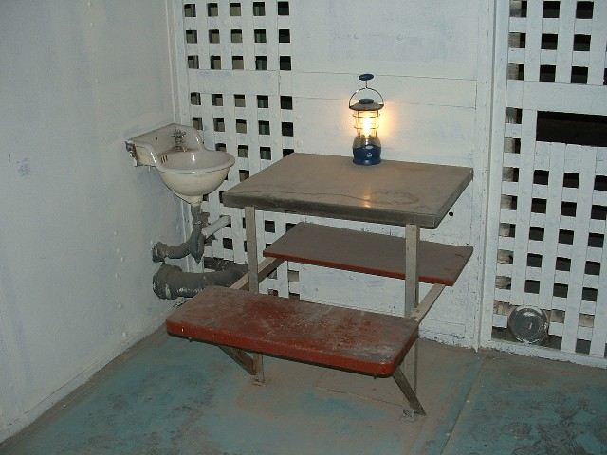
She watched the man leave and just as he left her sight, she heard the larger cellmate shout “I’m extra hungry today.” She turned to see him now in possession of both of her cellmates’ bread. Okay, maybe these 10 months won’t be such a walk in park after all. But then she took another look at the smaller one. She would have expected him to resist, perhaps at least complain, but instead he just sat down at the table, dejected, yet come to terms with his sort. It was obvious he had to keep up with this on a daily basis.
Well, if Sunspear was to spend the next ten months of her life in here, she’d better make some friends. She sat at the opposite end of the table. “Do you want half of my bread?”
He looked up and his eyes told Sunspear everything. Yes, he did want but he couldn’t comprehend why she would ever give it up. She broke her bread in half and offered one.
“Um, thanks, I guess,” he mumbled. That was a start.
“So what’s your name?” Sunspear pressed on as she chewed on her own breakfast. The good thing about this – she wouldn’t put on any more pounds this year.
“I’m Kenneth Danell, that guy’s Jack Colton. We’re both here for fraud. Four years.”
He started talking on his own; now that was a good sign. “I was a teacher at a school in Penzance. My name is Lucy Allen, but friends just call me Sunspear, so please get used to that.”
That made him blink a few times. “Friends, Miss Allen? Here, everyone just fends for himself. You will find no friends in Windswept.”
She smiled at him, “but I already have.”
Kenneth seemed to process that for a while and when he finally understood, he returned the smile, “Sunspear, you say? How did you come by that nickname?”
“Oh, well, when I was younger, I used to stare at the sun a lot. Others noticed.”
“And the spear?”
“I’m not sure,” she shrugged, “it could even be just a pear. I guess that’s one bit of knowledge lost to time forever. But I’ve grown attached to the name. I could tell you about the time I looked in the sun so long they had to drag me into the hospital…”

Influence
It was just over a week since her incarceration and Sunspear was entering the bathroom when she heard the scream from the men’s room, followed by the sound of a flurry of punches. And she had hoped she could just live through this in peace. But no, this was unacceptable, even from criminals.
She entered the men’s room to see a tall prisoner severely beating another who already had blood running from his face. That’s worse than what Sunspear thought, but calling in the guard would hardly solve the problem long-term. And she did want to live here for ten more months.
“That’s not very nice,” Sunspear frowned.
The tall guy just threw her an annoyed grunt. “This is the men’s bathroom. You get out of here.”
“No,” she shook her head, “because this is not how people act towards each other.”
He let go of the other guy who quickly scrambled to his feet and backed into a corner, “listen missy, I don’t know how long you have until you go free, but I’m here for life and this,” he pointed to the beaten guy, ”is fun, so I will keep doing that.”
“You want to be here forever?”
“What part of imprisoned for life did you not understand, girl?” he growled, “I committed murder, there’s no way those surface guys would want me back there.”
“I would, perhaps.”
The conversation obviously stopped making any sense whatsoever to the tall man, “you would? You would like me to murder your family while you sleep, perhaps?”
“What a terrible thing to say! Of course not! I just believe, I think, you wouldn’t. You know it’s wrong, you know crime hurts people, why would you ever want to hurt people, for goodness’ sake? How could you ever keep friends that way?”
He snorted, “murderers don’t have friends. We prefer it that way.”
“Now that hardly seems possible, doesn’t it?” Sunspear looked deep in his eyes, “say, why don’t you apologize to the poor man, and then we can all get some tea together, does that sound good, mister… em…?”
After a while, he shrugged, “I’m Thomas. You would really be a friend?”
“But of course! If you promise to behave, that is.”
At that, he walked to the corner and helped the other prisoner get up, “then I guess it’s worth a shot. I’m sorry for beating you, Jack.”
Sunspear didn’t know what made the inmates so receptive. People on the surface were all also somewhat gentler and happier around her, yet never did she such changes after a simple show of kindness and among imprisoned criminals to boot. Perhaps it was precisely the fact that they missed it for so long that helped. But the reason does not matter.
She had sworn she would dedicate her life to teaching. But why should she stop just because she is in prison? And why should she teach only Mathematics or Language? It is not common to teach friendship, sure, and it can’t really be done in a classroom setting, but these people require it much more than her class needs Math. And she had just the idea. She was sure the prison manager would agree.

Adequacy
“I do not understand,” said Jack.
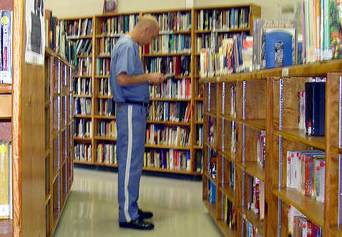
Sunspear looked up from her table. They were in the prison library that was currently bustling with life. Just a few days ago, Sunspear converted it into a kind of a clubroom where she and invited volunteers from the outside world came taught the prisoners intellectual skills. People were reading books, working at computers or writing stories. Some of them actually had university diplomas and they were glad they could return to these activities after years spent doing physical labor. The others found that they actually liked this.
Not at first, sure, but when Sunspear looked at them and talked to them, they changed. They wouldn’t say ‘no’ to her. And yet they didn’t do it for her – nor did they use it as an excuse to evade physical labor – they actually came to enjoy education more than bullying or sitting around.
“Well, you’re holding an Edgar Allan Poe poem book, Jack,” she said, “that goes in the Poetry section, under P. That’s the bookshelf over there.”
“Oh, not that,” Jack said, “I’m not an illiterate beast. You know, I am here because of tax evasion. I’m more than capable of sorting books.”
“Then what do you not understand?”
“To be blunt,” he hesitated, “it’s you, Sunspear. It had to take some doing to convince the prison manager, Safford, to give us this free time, all this material, the computers and I don’t even mention the specialists who come to teach us.
“You explain it to everyone. You always say you don’t need any personal profit, that you do this because it’s the right thing. But I don’t buy it. These people are criminals. Even if, as you say, you do this for altruistic reasons, it is still wrong. Everyone who’s here is guilty of a crime – they don’t deserve your sympathy, much less your help or even friendship.”
Sunspear sighed and motioned for him to take a seat, “three weeks ago, the day I first arrived in Windswept, you stole food from your cellmate. Why did you do it?”
“I was hungry. And I wanted to make sure you – as the new girl – understand who the boss around here is. The way it worked – you either got to beat people or you were beat by people.”
“You were doing this day by day, and yet – you didn’t steal a single crumb of bread since. Why is that?”
He got startled by that. “I… I wouldn’t know. But I guess it’s because of you somehow. I probably wanted to impress you or…”
“Or you knew it was the right thing not to steal. Tell me, how long are you in Windswept?”
“Three years. I have one year left to serve.”
“And what was your life before that?”
“I ran a general goods store on the outskirts of Exeter. I had a few employees. And a wife and two children. But they’re all gone now. After the first two years I was in prison, they just couldn’t handle it anymore. Not the separation, not the lack of money. We even divorced. The business also crumbled.”
“And if you were released from prison right now, what would you do?”
“I would come running to my family. Apologize. Beg them to accept me again. Failing that, I would try and build a new business. Use what I know, get a life. But, Sunspear, what does this have to do with anything?”
“You’ve answered your own question, Jack,” said Sunspear, “nowhere in your intentions did you say you intended to do harm. Yes, you did a stupid thing – it’s not right to evade taxes and in the overall view, it hurts people – but four years of prison is just a bit too harsh, don’t you think?
“And I’m fully willing to spend my ten months in here but for me, it’s not that much of a punishment. I actually came to like this place. For you, though, and for many others, this is a punishment out of proportion to your original crime.”
“Even for the murderers?”
“Even for them. The way I see it, by putting the murderers behind bars, the society shirks responsibility for them. It’s difficult to teach murderers, difficult to live with them. They can be “reformed” in a way, yet it is hard and costs not only money but also emotional care that nobody is willing to give. So the society takes the easy way out – it just singles out people who are difficult to live with and imprisons them.
“I believe that through making friends and opening up, many – if not all – of these prisoners can become better people than most who live free. They will cease to want to cause harm or want profit at the cost of others.”
Jack nodded and stayed silent for a long time after that. Then he got up and continued sorting the books. And this was a bully who owned the prison when she came in. And today, Sunspear had a discussion with him about philosophy, of all things. I guess it just goes to show, there is always hope and that at the core, we are all basically good.
“Um, Sunspear?” called a prisoner from one of the computers, “could you please help me with this formula? I can’t seem to get it right.”
“I’m coming, Helen.”

For Whom The Prison Works
“…to reiterate, I fully acknowledge I did the crime,” said Helen, stacking her notes neatly in front of her, “I did upload a lot of software and I did upload a lot of music. I recognize people have lost money because of me. But hey, that’s enough for imprisonment? Seriously?
“Like Sunspear, I was a teacher. One of the things you’re taught in pedagogy is that you shouldn’t have one catch-all punishment for all inappropriate behavior. Yet that is exactly what our justice system is. You committed murder? Jail. Rape? Jail. Money laundering? Jail. Breaking into a computer database? Jail. Burglary, bribery? Jail. I mean, have the policy-makers no imagination?
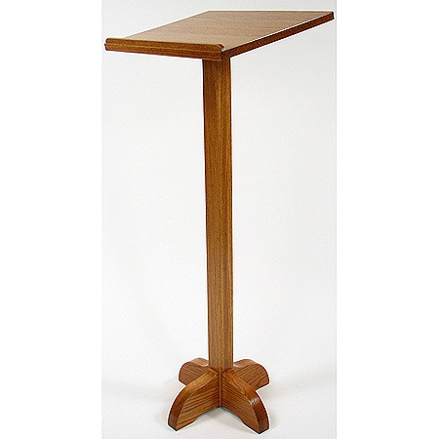
“So, in conclusion, I present the case that imprisonment does serve as a repression and does protect the society from those who would do harm, but it essentially ruins the lives of those who are imprisoned. And that is not acceptable.”
A wide round of applause went up from the inmates as Helen left the speaker’s table. Sunspear motioned for another prisoner who frequented her “debate hour” to go to stage.
A short, bald man, Chris nodded to Helen, “yeah, right, I’m sure most of us in here would agree with the previous speaker’s sentiment,” he waited for the laughs to cease, “yeah, that’s what I thought. And to an extent, I can see the merits of Helen’s argument. But let’s review the types of criminals, yeah?
“First, we have those who committed no crime but had a bad attorney, like Chuck here. I agree prisons aren’t for them. (more laughter)
“Second, some committed crime through negligence, like Sunspear. Here, again, I agree, a punishment – if one is appropriate – should be something far different from prison.
“But then we get to the people I want to talk about: murderers, sociopaths, burglars. Time and time again, it has been shown – by respectable scientists, yeah, from America – that even when those people leave prison, they just commit the crimes again! And what else can they do, right? We don’t live in bloody communism – the unemployment rate is over ten percent. These people have no discernable skills. They wouldn’t survive outside prison walls.
“And what about drug addicts? Sure, here in Windswept, it’s getting better. Seems that what Sunspear’s doing helps them with their problems. But she can’t be everywhere. Not to mentions she must getting pretty sick of talking to people likes us, right?”
This time, the laughter was quickly cut by Sunspear. “No, Chris, I really do have the time of my life here. Your point remains valid, however. Please continue.”
Chris recomposed himself. “Yeah, right. Well, as I said, those kinds of people just can’t be helped. We should isolate them to prevent harm to others.”
“But what about Sunspear’s draft of the Monastery Net? That solves all of the problems you presented,” said Helen.
“Yeah, if you can make it work. The holes in that project are so big that I don’t see how it doesn’t fall through itself.”
“It’s a draft. But you’ve got to admit it has potential. A network of monasteries all over the world –“
“It’s crap and you know it. It’s just a meaningless wall of text –“
Helen stood up, “don’t you dare talk about Sunspear’s project that way.”
“Hey, freedom of speech, right? Not everything Sunspear says is gold.”
“How can you say that after all she’s done here?”
Sunspear moved to the speaker’s table and tapped at her watch, “well, this is getting a little off-topic and we should just about finish anyway. Thank you all for attending. Next time, we’re debating the logical arguments for and against the existence of a god, so come prepared.”
A raised hand. “What is the Monastery Net, Sunspear?”
“Nothing more than an idea I had. Something similar to monastic orders of the past. Monks – people dedicated to their vocation – who would live and work with criminals. These monasteries would replace traditional prisons. The chief difference between the two would be the relationship between the condemned and the guards/monks. Whereas in prison, the guards maintain an adversary relationship with the inmates, in the monasteries, the monks would, to the contrary, befriend and reform criminals.
“Their life would be very different from the life of guards. For them, it wouldn’t be a 9-to-5 job they do to earn money for their family. For them, reforming criminals would be their life’s ultimate goal.”
“Are there any people like that?”
Sunspear looked down, “there might be.”

Court (part 2)
“You are the Prison Manager, correct?” asked the judge.
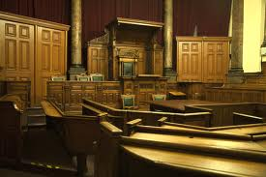
“Yes, sir,” said Safford, “Miss Allen is of the inmates.”
The judge folded his hands, “and how would you describe her behavior, Mr. Safford?”
Safford had to suppress a smile at that, “I have never seen anything like it. Ever since her incarceration the behavior of all the inmates improved significantly. They no longer act like criminals, but more like… well, for the lack of a better word, a family.”
“You hardly described her behavior, Mr. Safford,” said the judge.
“I didn’t? She was exemplary, Your Honor, way better than exemplary. It is thanks to her that my prison is now a heaven compared to the city streets. With all due respect, Your Honor, I can’t believe how you could have convicted her in the first place. Her crime was… an accident, a mistake. Sunspear, I mean, Miss Allen, is the kindest person I have ever met. She never deserved a prison sentence.”
The judge frowned, “alright then. Does the attorney have anything else to add to the case? No? In that case, everyone rise.”
The entire room stood up, everyone tense. This was the first case where a person requested parole a mere two months after incarceration. It was Safford who made the proposal, really, and it was he who paid for the attorney. After the change Sunspear brought about in the prison, he swore he would do all he could to help her.
“In the name of the Republic, I release Miss Lucy Allen on parole. She may leave the Windswept Prison immediately and her criminal record shall be purged on condition she commits no crimes in the following two years. Miss Allen’s conduct while imprisoned was above exemplary, she has shown regret and it is clear that while she had been negligent, the deaths were caused much more by coincidental accidents than the subject’s errors. The court deems she represents no danger to the general public.”

Fin
Sunspear sighed. It was over. She paid for her crime and could hopefully get back to her life. Then she looked over the courtroom and saw it still full of inmates, talking excitedly or clapping hands. She smiled. It was not easy to live in a prison and it will still have repercussions but even now, she felt it may have been a good thing after all. She may have done more good here than during her entire life before and in fact, she may have made more friends here than in the outside world.
And as she smiled and stood up, the entire room fell silent, all eyes on her. “I must go to my family now, and reunite with my friends and… and do something for the Archers and the other families. But I will never forget you nor will I abandon you. We are all to blame and we have all made mistakes. But I know you will do all you can to correct them. I will be back, I promise.”
And at that, the entire hall erupted into cheers and hurried to shake Sunspear’s hand, to congratulate her, to thank her. The officers did not try to stop them.
As the inmates finally filled out from the hall, the judge turned to his assistant and said: “You know, if she continues this way, we may have no more need for prisons on this Earth.
“And then I could take a vacation.”

Written in June 2013
Final editing in October 2013
Petr Hudeček

